Test Case: tc001_SPX_Dev5_Crear_Nueva_Linea_Requisicion_Spot_Tipo_Cobro_CC
Step 1 - Enter username and password and click to button Enter : Credentials Entered
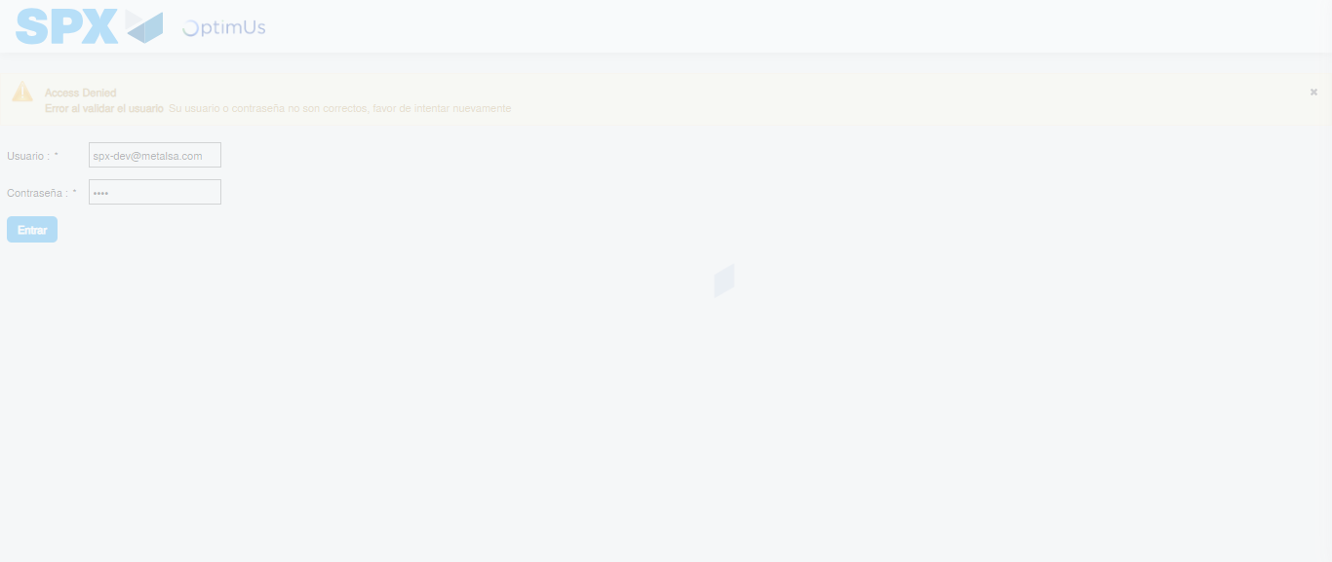Image file-name: QC_Testing-tc001_SPX_Dev5_Crear_Nueva_Linea_Requisicion_Spot_Tipo_Cobro_CC-1790175338273

Step 2 - Select to UEN and Access to Spot Buy Requisitions : UEN Correctly selected and Correct access
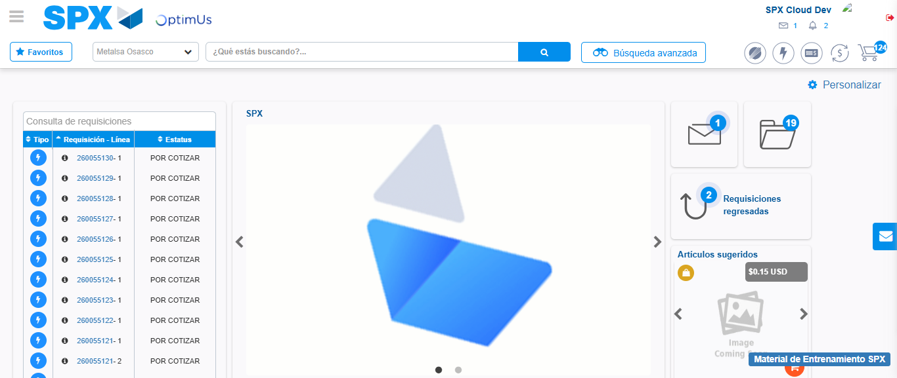Image file-name: QC_Testing-tc001_SPX_Dev5_Crear_Nueva_Linea_Requisicion_Spot_Tipo_Cobro_CC-1790175375681

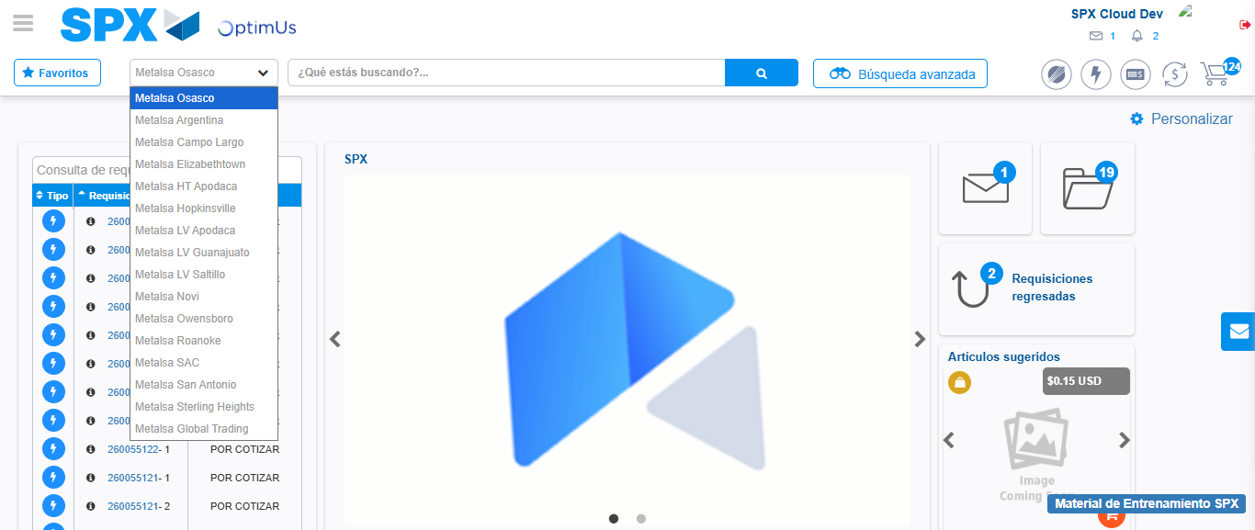Image file-name: QC_Testing-tc001_SPX_Dev5_Crear_Nueva_Linea_Requisicion_Spot_Tipo_Cobro_CC-1790175376409

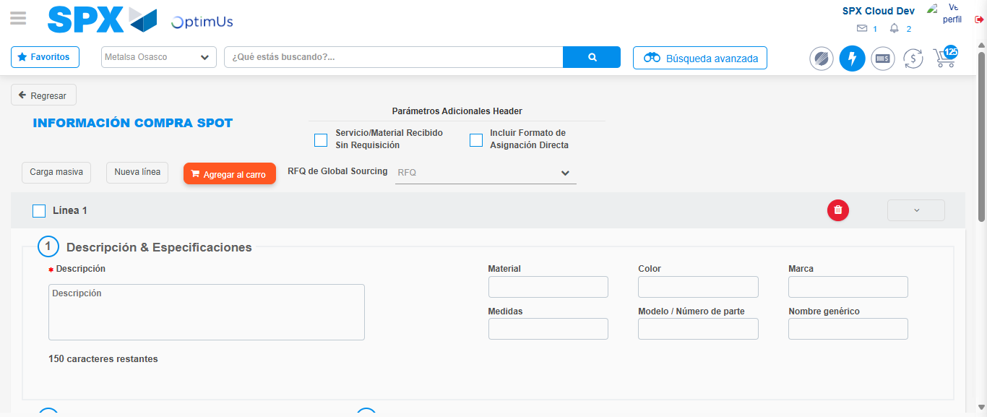Image file-name: QC_Testing-tc001_SPX_Dev5_Crear_Nueva_Linea_Requisicion_Spot_Tipo_Cobro_CC-1790175390846

Step 3 - Data Capture Spot Buy Requisition: Data captured correctly
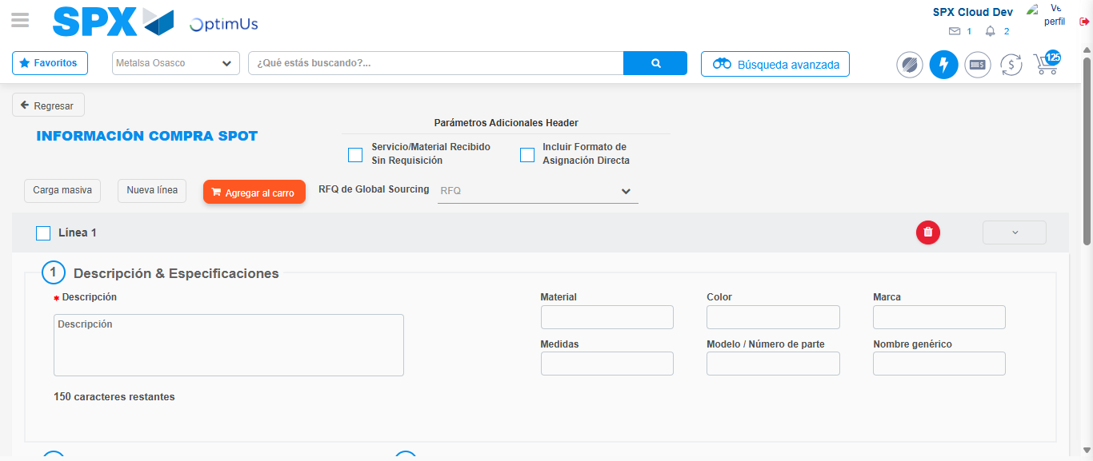Image file-name: QC_Testing-tc001_SPX_Dev5_Crear_Nueva_Linea_Requisicion_Spot_Tipo_Cobro_CC-1790175391168

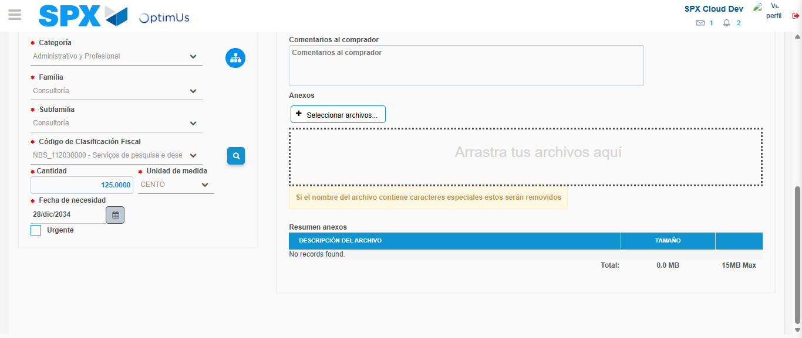Image file-name: QC_Testing-tc001_SPX_Dev5_Crear_Nueva_Linea_Requisicion_Spot_Tipo_Cobro_CC-1790175408238

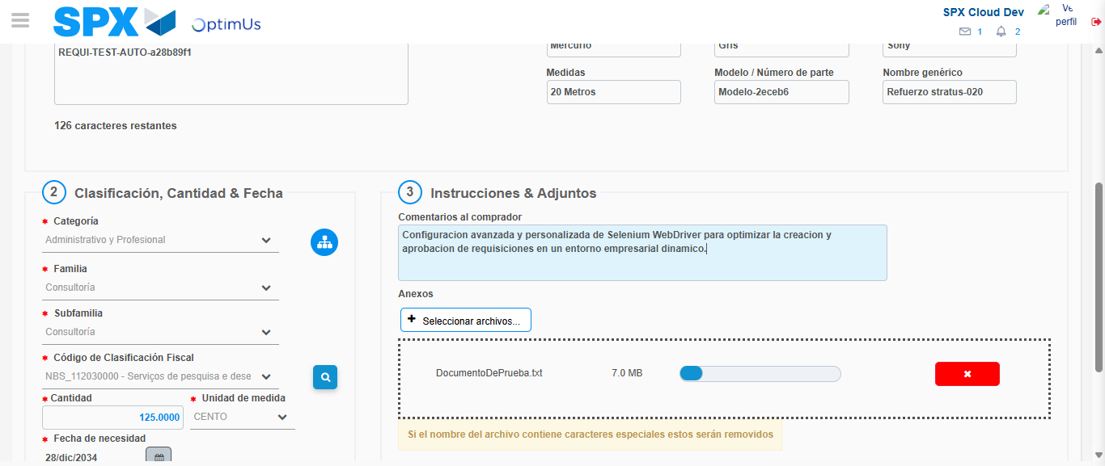Image file-name: QC_Testing-tc001_SPX_Dev5_Crear_Nueva_Linea_Requisicion_Spot_Tipo_Cobro_CC-1790175409160

Step 4 - Add new line and data capture second line: Line add correctly
Image file-name: QC_Testing-tc001_SPX_Dev5_Crear_Nueva_Linea_Requisicion_Spot_Tipo_Cobro_CC-1790175391168

Image file-name: QC_Testing-tc001_SPX_Dev5_Crear_Nueva_Linea_Requisicion_Spot_Tipo_Cobro_CC-1790175408238

Image file-name: QC_Testing-tc001_SPX_Dev5_Crear_Nueva_Linea_Requisicion_Spot_Tipo_Cobro_CC-1790175409160

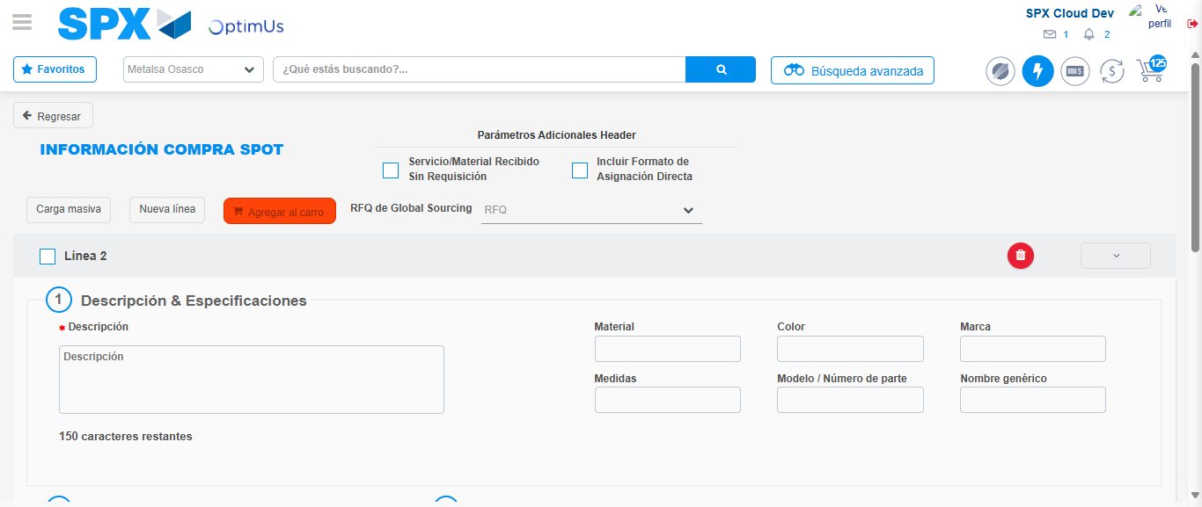Image file-name: QC_Testing-tc001_SPX_Dev5_Crear_Nueva_Linea_Requisicion_Spot_Tipo_Cobro_CC-1790175411498

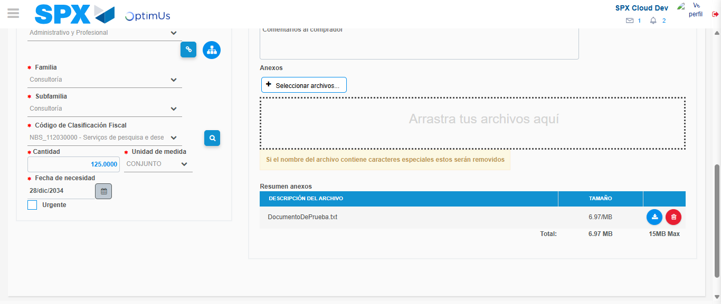Image file-name: QC_Testing-tc001_SPX_Dev5_Crear_Nueva_Linea_Requisicion_Spot_Tipo_Cobro_CC-1790175428674

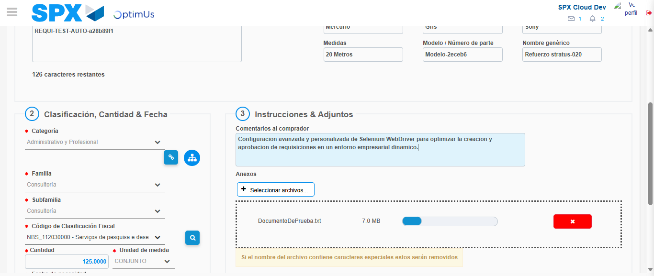Image file-name: QC_Testing-tc001_SPX_Dev5_Crear_Nueva_Linea_Requisicion_Spot_Tipo_Cobro_CC-1790175429631

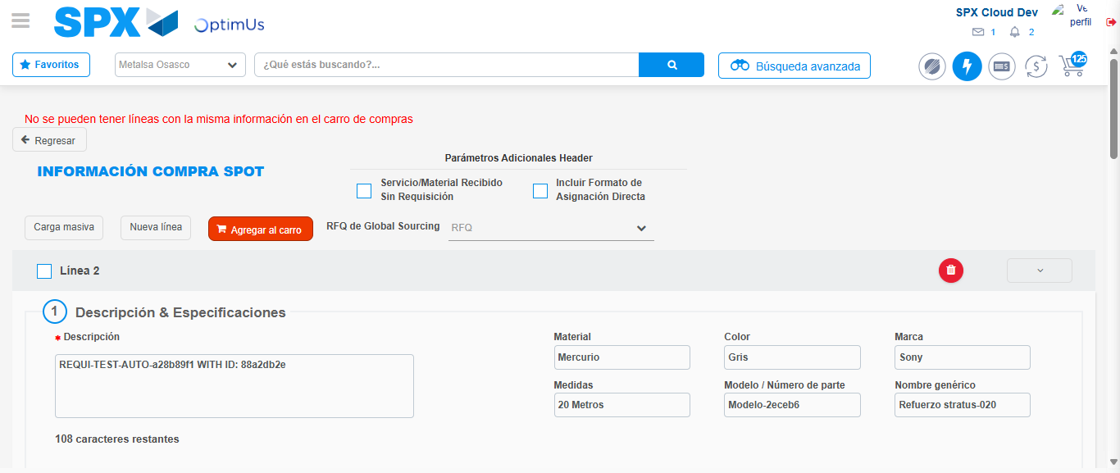Image file-name: QC_Testing-tc001_SPX_Dev5_Crear_Nueva_Linea_Requisicion_Spot_Tipo_Cobro_CC-1790175436353

Step 8 - Return to Main Page SPX : Return to Main Page SPX
Image file-name: QC_Testing-tc001_SPX_Dev5_Crear_Nueva_Linea_Requisicion_Spot_Tipo_Cobro_CC-1790175375681

Image file-name: QC_Testing-tc001_SPX_Dev5_Crear_Nueva_Linea_Requisicion_Spot_Tipo_Cobro_CC-1790175376409

Image file-name: QC_Testing-tc001_SPX_Dev5_Crear_Nueva_Linea_Requisicion_Spot_Tipo_Cobro_CC-1790175390846

Image file-name: QC_Testing-tc001_SPX_Dev5_Crear_Nueva_Linea_Requisicion_Spot_Tipo_Cobro_CC-1790175438580

Image file-name: QC_Testing-tc001_SPX_Dev5_Crear_Nueva_Linea_Requisicion_Spot_Tipo_Cobro_CC-1790175438771

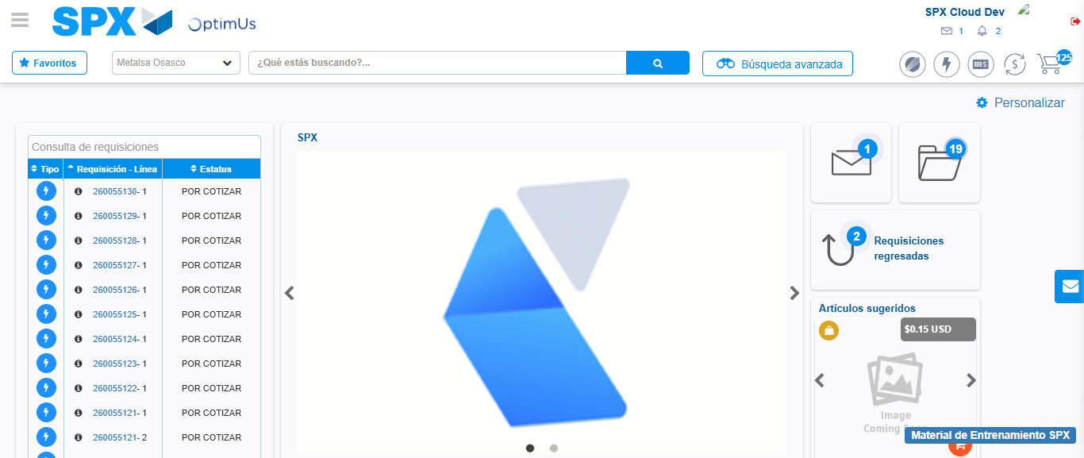Image file-name: QC_Testing-tc001_SPX_Dev5_Crear_Nueva_Linea_Requisicion_Spot_Tipo_Cobro_CC-1790175459845

Step 9 - Log Out : Log Out SPX
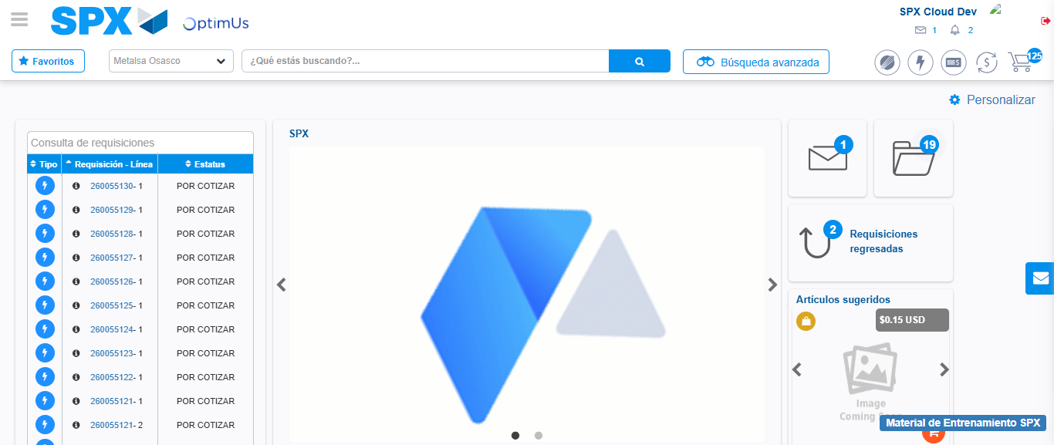Image file-name: QC_Testing-tc001_SPX_Dev5_Crear_Nueva_Linea_Requisicion_Spot_Tipo_Cobro_CC-1790175460172

